Case 5-Asia-Japan-Haniwa-Bust of Warrior with Helmet-Kofun Period-250 to 538 CE
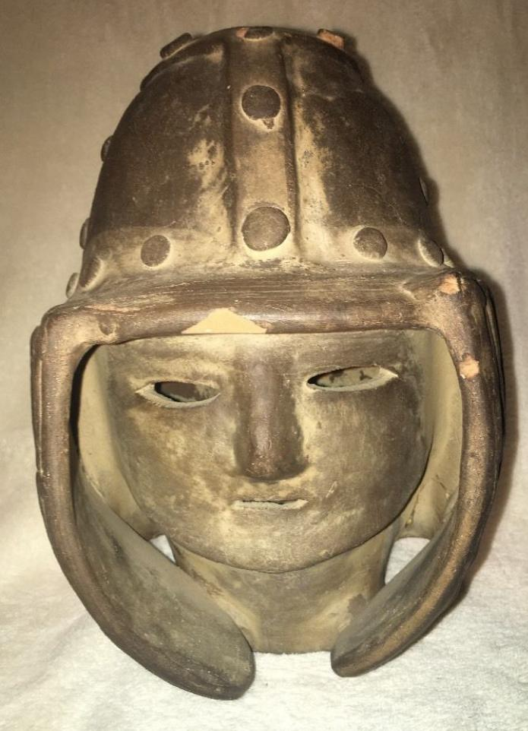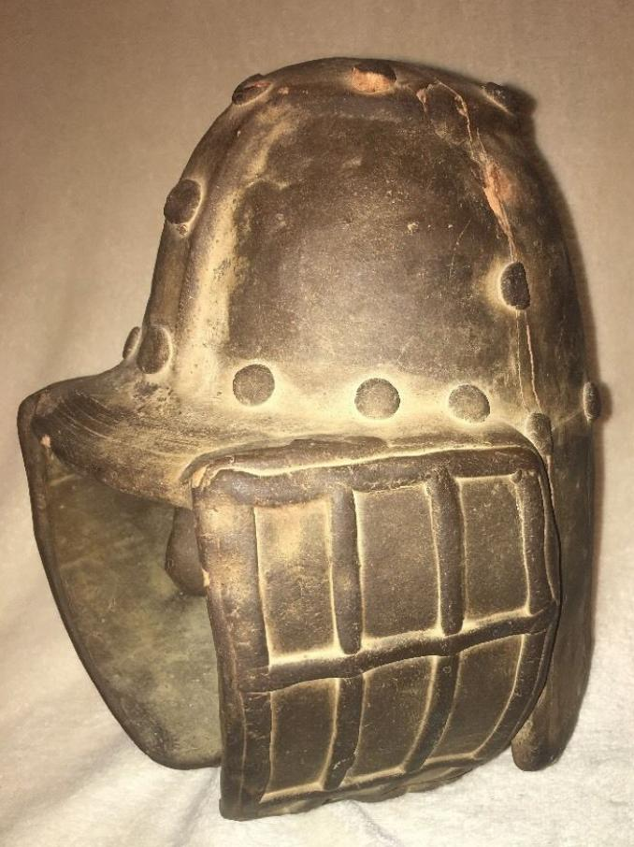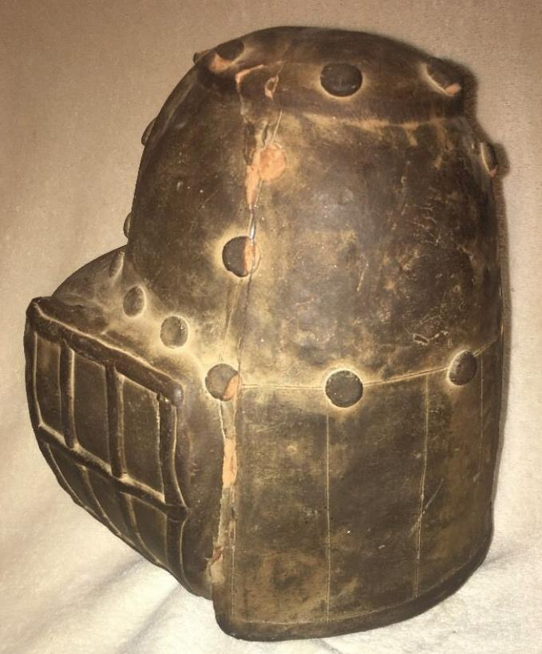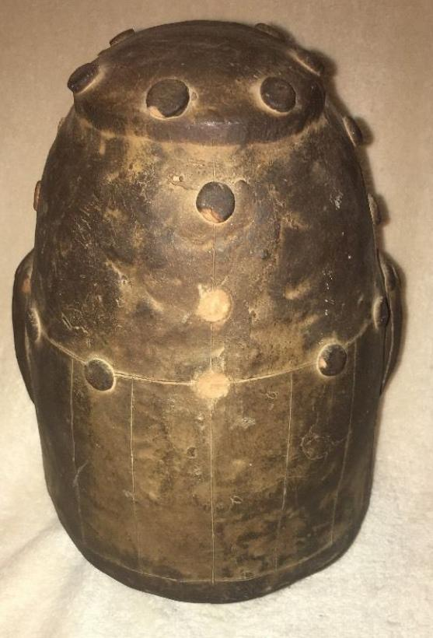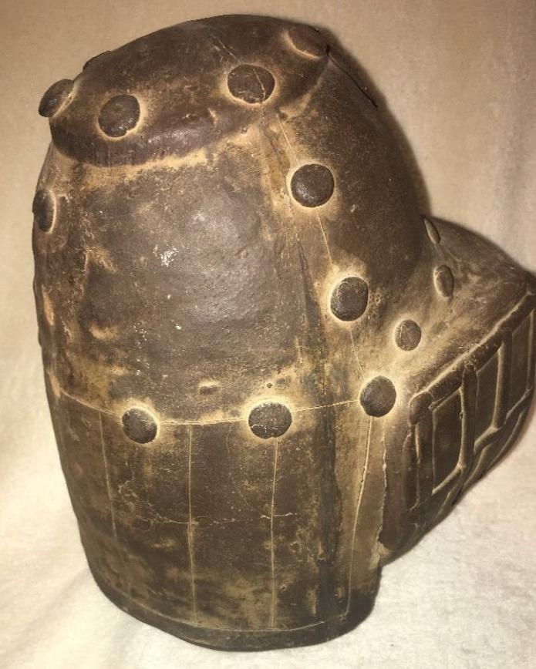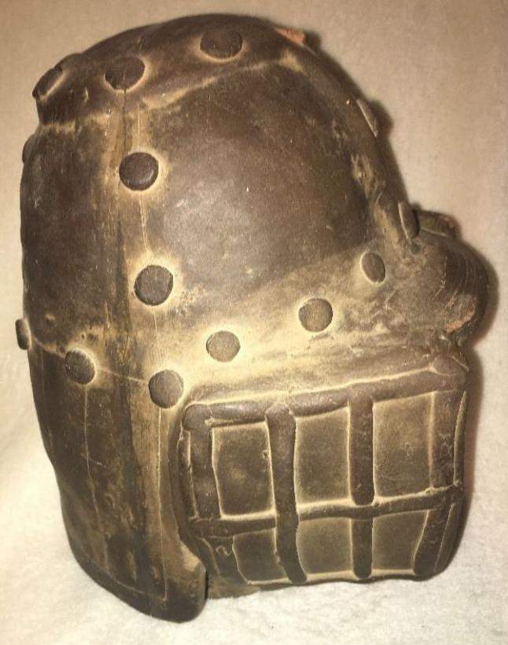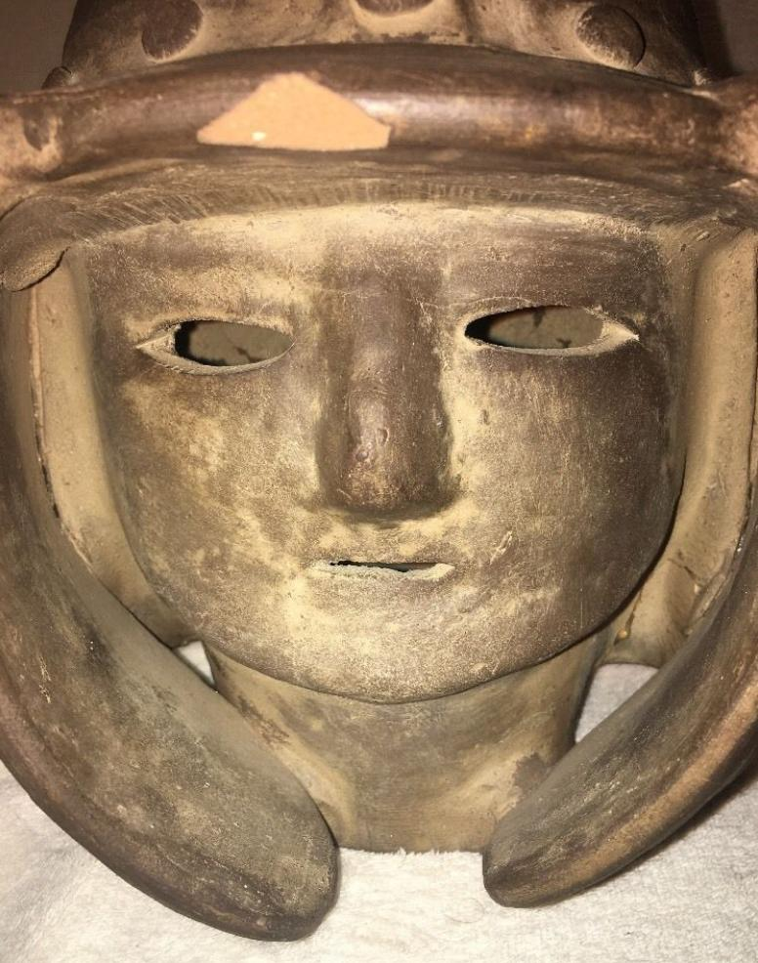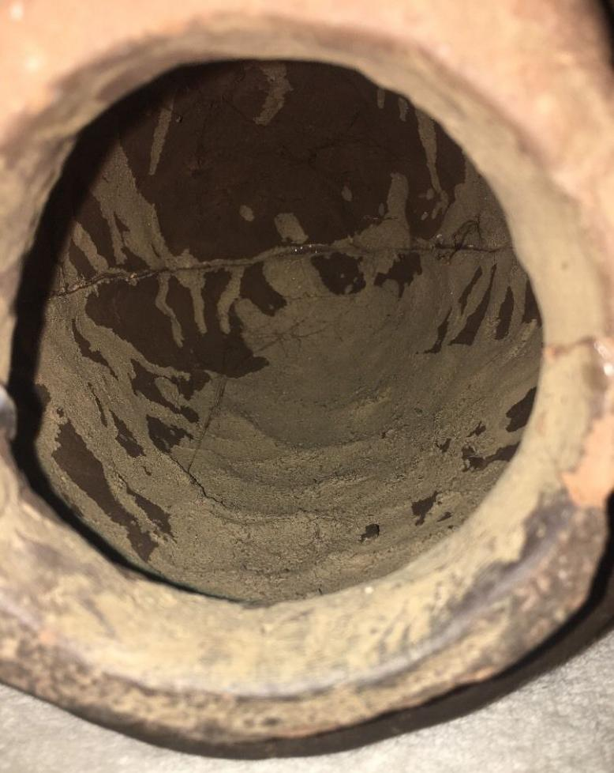
Formal Label: Japanese Haniwa Haniwa-Bust of Warrior with Helmet, Kofun Period, 250-538 AD-CE
Accession Number: NB 1667.A2
Date or Time Horizon: 250 to 538 AD-CE
Geographical Area: Japan
Cultural Affiliation: Kofun Period
Medium: Terracotta
Dimensions: 10 in
Weight:
Provenance: U.S. Naval Captain, Occupied Japan, 1947.
Condition: Mended cracks.
Discussion: This head of a man with helmet and cheek pieces provides a detailed picture of hos strips of metal were riveted to construct the helmet with the cheek pieces bent around the head and reinforced with a grating that looks welded on.
References: Miki, Fumio. 1961. Haniwa : the clay sculpture of protohistoric Japan / English adaptation by Roy Andrew Miller. Rutland, Vt./ Tokyo, Japan: C.E. Tuttle, [1961]

